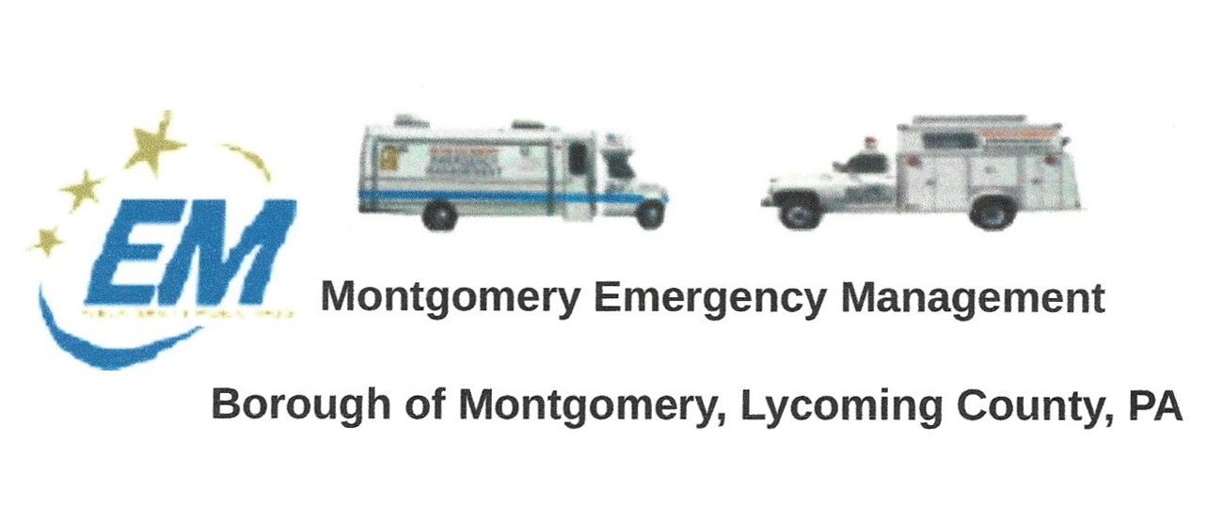
The regular monthly meeting of the Montgomery Borough Emergency Agency will be:
Greg Gruver, EMA Coordinator. 77 East Houston Avenue, Montgomery, PA 17752
Telephone: 570-547-1212. Cell: 570-419-4866. Email: montema631@gmail.com
Fae Herb, Administrative Assistant. 102 Broad Street, Montgomery, PA 17752
Cell: 570-506-9892. Email: faeherb@aol.com
Meeting Room and Equipment Building: 40 Thomas Avenue
Borough EOC: 570-547-1671 Fire Hall EOC: 570-547-1380
INTERNET WEBSITE: WWW.montgomeryboroughema.org

January 20, 2022
November was a quiet month for the EMA as we brace ourselves for the cold weather. Unfortunately, COVID hit some members of our group and we were unable to have a quorum for our November meeting. December’s news of deadly tornadoes hitting six states makes us aware of how important it is for our volunteers to be trained and prepared for any emergency. The Montgomery EMA is made up of volunteers who each have their own skills, from FEMA training, water rescue, and radio experience. Working with other agencies throughout the year. We are always looking for more people to continue the service not only to our community but also neighboring communities and counties.
On Saturday, December 18th, 10 a.m. at Fairview Cemetery , the EMA will assist the Montgomery Legion Auxiliary with “Wreaths Across America”. Providing a sound system and music as the Auxiliary will place 245 wreaths to Honor the Veterans who lie in rest at Fairview Cemetery.
Also, our members will be busy assisting with the Montgomery Christmas Committee Toys For Tots. Picking up food, preparing the food boxes and most of all picking up the toys at various locations so they can be wrapped. A huge thanks goes out to Jodi Ellis and Virginia Hill, who spends hours wrapping and tagging the gifts, bagging up so “Santa’s helpers” can deliver on Christmas Eve morning. A tradition for our community for over 50 years. Deputy Coordinator Dennis Gruver and his wife Nancy managed the Christmas Committee for over 40 years, Dennis will be speaking at the Montgomery Area Historical Society (located below the Public Library) on Thursday, December 16th at 6:30 about the Christmas Committee. The public is invited to enjoy the program and share in their First Annual Christmas Party.
I would personally like to thank all the members for their support, help and most of all patience as I adjust to the position of Administrative Assistant. Unlike our new Coordinator, Greg Gruver who follows his father’s tenure, I did not grow-up within the organization. My predecessor, Leslie Gruver, having over 50 years’ experience has been an enormous help to me as well as Dennis and Greg. I wish everyone a very Merry Christmas, a safe and Happy New Year. Let us hope we do NOT have a repeat of last Christmas Day !!!
Fae Herb
Administrative Assistant

